House Hub

Smart Rental Property Management Platform

Project Documentation

1. Introduction

Project Title
House Hub – Rental Service
Repository https://github.com/Sowmya_2602/HouseHub

Team Members
Team Member | Role
Sowmya Gunupudi (24481A05C2 CSE) | Team Leader
Rakesh Muthyala (24481A05O4 CSE) | Team member
Snehalatha Kattupalli | Team member
Purnaambika G (24481A05B9 CSE) | Team member
Sumiya Abdul (24481A05X9 CSE) | Team member
Mentor: No Mentor Assigned

2. Project Overview

Purpose
House Hub is a web-based rental service platform designed to simplify the process of finding, listing, and managing rental properties. It provides a centralized platform where property owners can list their properties and tenants can search, compare, and rent homes based on their preferences such as location, budget, property type, and available amenities. The application integrates secure user authentication, property management, and an intuitive interface to ensure a seamless and efficient rental experience for both landlords and tenants.

Features
- User registration and secure login for landlords and tenants.
- Property listing and management with details such as rent, location, images, and amenities.
- Advanced property search and filtering based on location, price range, property type, and other preferences.
- Property details page with images, descriptions, contact information, and rental specifications.
- Landlord dashboard for adding, editing, and removing property listings.
- Responsive and user-friendly web interface accessible across desktops, tablets, and mobile devices.
- Tenant inquiry and communication features to connect directly with property owners.
- Secure database integration for storing user accounts, property information, and rental records.
- Fast and reliable performance using a modern web application framework for efficient property browsing and management.

3. Architecture

Frontend:
Built using HTML, CSS, Bootstrap, and JavaScript to provide a responsive and user-friendly interface. The frontend allows users to register, log in, browse available rental properties, search and filter listings based on location, budget, property type, and amenities. Property details, images, and contact information are displayed dynamically, ensuring a smooth and interactive user experience across different devices.
Backend
Built using Flask (Python) with modular functions handling user authentication, property management, search operations, form validation, and database interactions. The backend processes user requests, manages property listings, stores and retrieves rental information, and ensures secure communication between landlords and tenants. It also handles user sessions and validates all input before processing.
Database / Data Layer
The application uses a MySQL database (or your database system) to securely store user accounts, property listings, landlord and tenant information, booking/inquiry details, and uploaded property images. The data layer supports efficient CRUD (Create, Read, Update, Delete) operations, enabling users to add, update, delete, and search rental properties. Database optimization techniques ensure fast retrieval of property information and reliable system performance.
Note: This project uses a trained ML model file rather than a traditional database (e.g., MongoDB). If a database is used for storing user inputs, history, or logs, add its schema and details here.

4. Setup Instructions

Prerequisites
• Node.js (v18 or later)
• npm (comes with Node.js)
• MongoDB Community Server
• MongoDB Compass (optional, for database management)
• Visual Studio Code (or any IDE)
• Git
Required Packages
Frontend (Client)
• React
• React Router DOM
• Axios
• Tailwind CSS (if used)
• Vite
Backend (Server)
• Express.js
• Mongoose
• CORS
• dotenv
• Nodemon (development)
Installation

1. Clone the Repository

git clone https://github.com/<sowmya_2602>/House-Hub.git

cd House-Hub

2. Install Client Dependencies

cd client

npm install

3. Install Server Dependencies

Open another terminal:

cd server

npm install

Or install required packages manually:

npm install express mongoose cors dotenv

npm install --save-dev nodemon

4. Configure Environment Variables

Create a file named .env inside the server folder.

PORT=5000

MONGO_URI=your_mongodb_connection_string

Example:

PORT=5000

MONGO_URI=mongodb://127.0.0.1:27017/househub

5. Start the Backend Server

cd server

npm start

or

node server.js

6. Start the Frontend

Open another terminal:

cd client

npm run dev

7. Open the Application

Frontend:

http://localhost:5173

Backend:

http://localhost:5000

5. Folder Structure

The structure below is a suggested Flask project layout. Replace with the actual structure from the repository.

Project Root

House Hub/

│

├── client/

│ ├── src/

│ ├── public/

│ ├── package.json

│ └── vite.config.js

│

├── server/

│ ├── models/

│ ├── routes/

│ ├── controllers/

│ ├── middleware/

│ ├── config/

│ ├── .env

│ ├── server.js

│ └── package.json

│

└── README.md

6. Running the Application

Start the Backend Server
cd server
node server.js
By default, the app will be available at:
http://localhost:5000/

Start the Frontend Application
cd client
npm run dev

By default, the app will be available at:
http://localhost:5173/

7. API Documentation

The endpoints below are inferred from the project description. Verify against app.py and update method names, parameters, and example responses as needed.
POST /api/auth/register

Registers a new user (Admin, Owner, or Tenant).

Request Parameters:

name

email

password

phone

role

Example Response:

{

"message": "User registered successfully",

"userId": "64f123456789"

}

POST /api/auth/login

Authenticates a user and returns login details.

Request Parameters:

email

password

Example Response:

{

"message": "Login successful",

"token": "jwt_token",

"role": "Tenant"

}

GET /api/houses

Returns the list of all available rental houses.

Example Response:

{

"houses": [

{

"houseId": 1,

"location": "Hyderabad",

"rent": 12000,

"bedrooms": 2

}

]

}

POST /api/houses

Allows an owner to add a new rental property.

Request Parameters:

ownerId

location

building

rent

deposit

bedrooms

description

Example Response:

{

"message": "House added successfully"

}

POST /api/bookings

Allows a tenant to book a rental house.

Request Parameters:

tenantId

houseId

bookingDate

Example Response:

{

"message": "Booking request submitted successfully"

}

GET /api/bookings

Returns all booking details for the logged-in user.

Example Response:

{

"bookings": [

{

"bookingId": 101,

"houseId": 1,

"status": "Pending"

}

]

}

These endpoints are much more appropriate for your House Hub project than the /predict endpoint used in the crop recommendation system.

8. Authentication

The House Hub application implements user authentication and authorization to provide secure access to the system.
Authentication Features
- User Registration
- User Login
- Role-based Access (Admin, Owner, Tenant)
- Password Validation
- Secure Session Management (or JWT Authentication, if implemented)
Authentication Flow
- Users register by providing their name, email, phone number, password, and role.
- Registered users log in using their email and password.
- The server verifies the credentials.
- Upon successful authentication, users are granted access to their respective dashboards based on their role.
- Unauthorized users cannot access protected resources.

9. User Interface

Add screenshots or GIFs of the input form, prediction results page, and any dashboards here.

10. Testing

Testing is performed to ensure the proper functioning of the House Hub application and to provide a smooth user experience. The following testing activities were carried out:
Then continue with your bullet points:
- Frontend testing of all pages (Home, Login, Registration, Property Listing, Property Details, Contact, Dashboard).
- Backend testing of user authentication, property management, and database operations.
- Form validation testing for login, registration, and property submission.
- Database testing to verify CRUD operations and data integrity.
- Responsive testing across desktop, tablet, and mobile devices.
- Performance and usability testing to ensure fast loading and smooth navigation.

11. Screenshots or Demo Link :
https://drive.google.com/file/d/1hdviRAOs7q5UcTIp5KS3UgbK0SoBoig3

Screenshot: example-1:

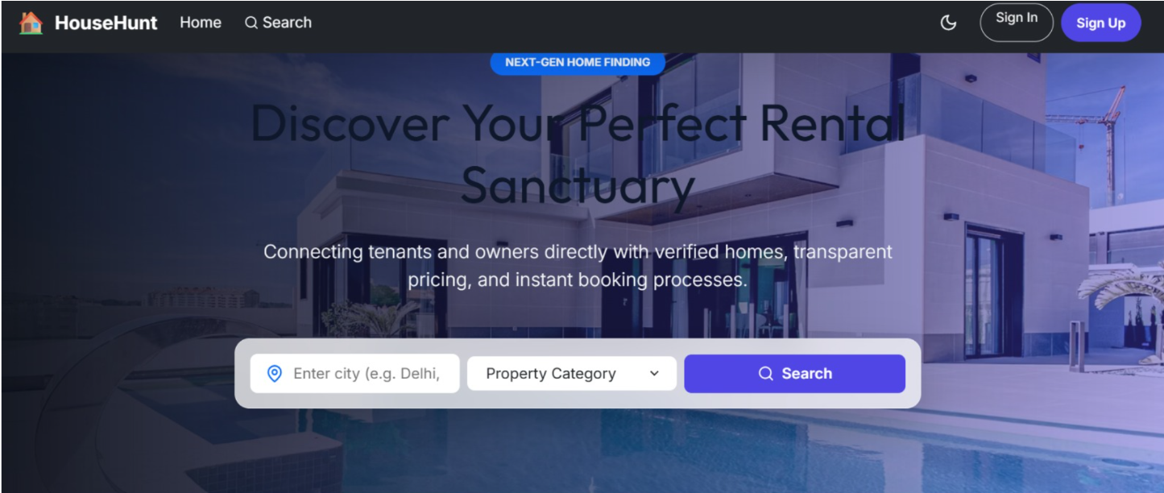

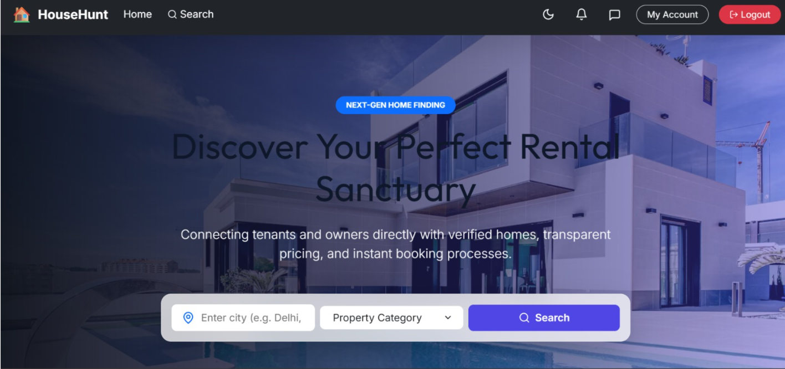

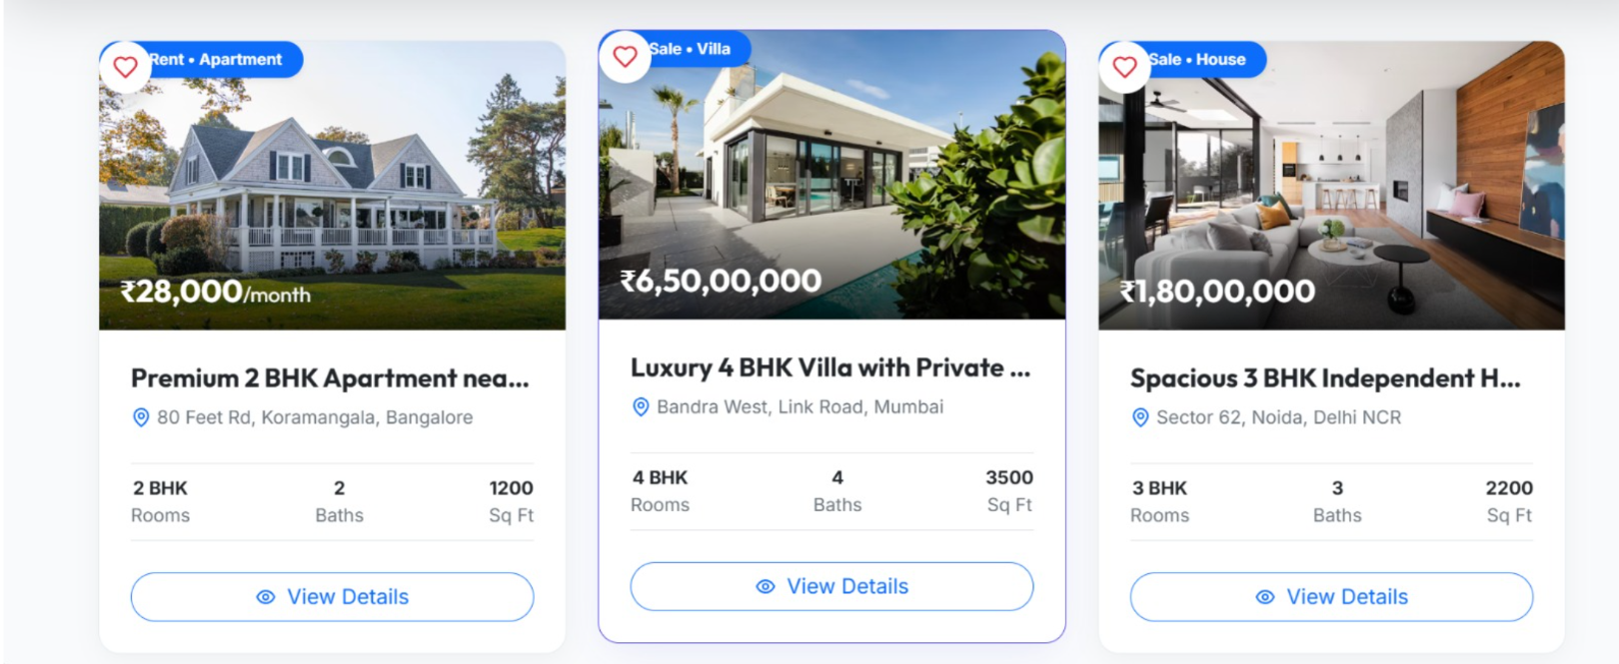
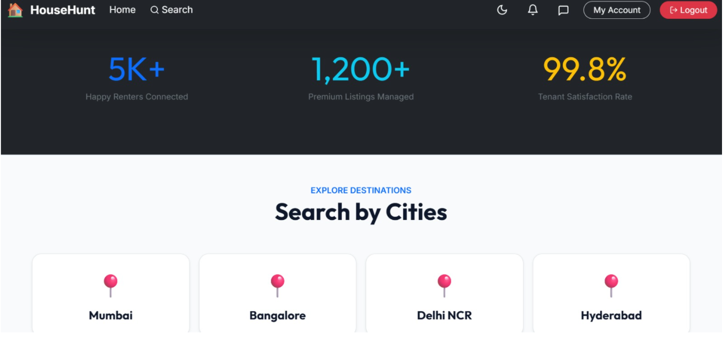

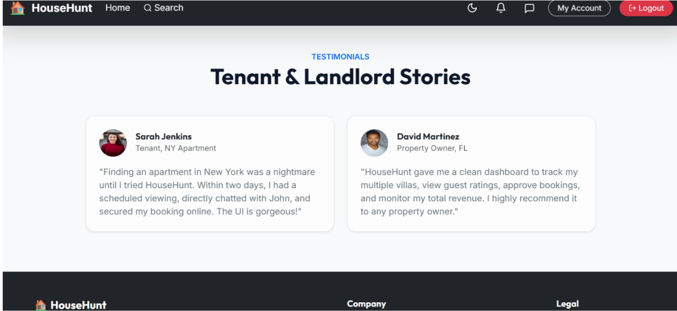

12. Known Issues

Document any known bugs or limitations here, e.g., dataset coverage limited to specific crops/regions, no database persistence, no user authentication yet.
13. Future Enhancements
- Add a database layer to store user queries and recommendation history
- Introduce user authentication and personalized dashboards
- Expand the dataset to cover more crops and regional variations
- Deploy the application to a cloud platform for public access
- Add visual analytics/dashboards for researchers and policymakers

